**GDP Assessment Questions**

**1. *A restaurant buys strawberries to make a smoothie. The purchase of the strawberries is added to GDP under consumption.***

a) True

b) False

***2. Which of the following macroeconomic indicators is real GDP per capita generally correlated with? Mark all that apply.***

a) Literacy

b) Life expectancy

c) Happiness

d) Poverty

***3. If real GDP is $100 and the number of people in a country is 20, then real GDP per capita in that country is:***

a) $5

b) $100

c) $200

d) $2000

***4. Prices typically rise for similar goods over time, the economic term for this is______.***

a) Nominal GDP

b) Real GDP

c) Inflation

d) Deflation

e) Annoying

***5. Which GDP measure best approximates the standard of living over time?***

a) Nominal GDP

b) Real GDP

c) Nominal GDP per capita

d) Real GDP per capita

***6. Which of the following are NOT included in GDP? Mark all that apply.***

a) A father taking care of his toddler

b) A professional nanny taking care of a toddler

c) An economics tutor teaching her students about GDP

d) Looking up GDP on Wikipedia

e) Buying a used record

f) Purchasing a new electronic music record

***7. A customer buys a strawberry smoothie from a restaurant. The purchase of the smoothie is added to GDP under consumption.***

a) True

b) False

***8. Imported oranges to the United States from the Dominican Republic are counted towards which country’s GDP?***

a) The U.S.

b) The Dominican Republic

***9. The price of coffee increases, but the amount sold remains the same. What would increase?***

a) Nominal GDP

b) Real GDP

***10. If a country’s nominal GDP increases by 100% from one year to the next, which of the following variables likely increased the most?***

a) Literacy

b) Inflation

c) Happiness

d) Life expectancy

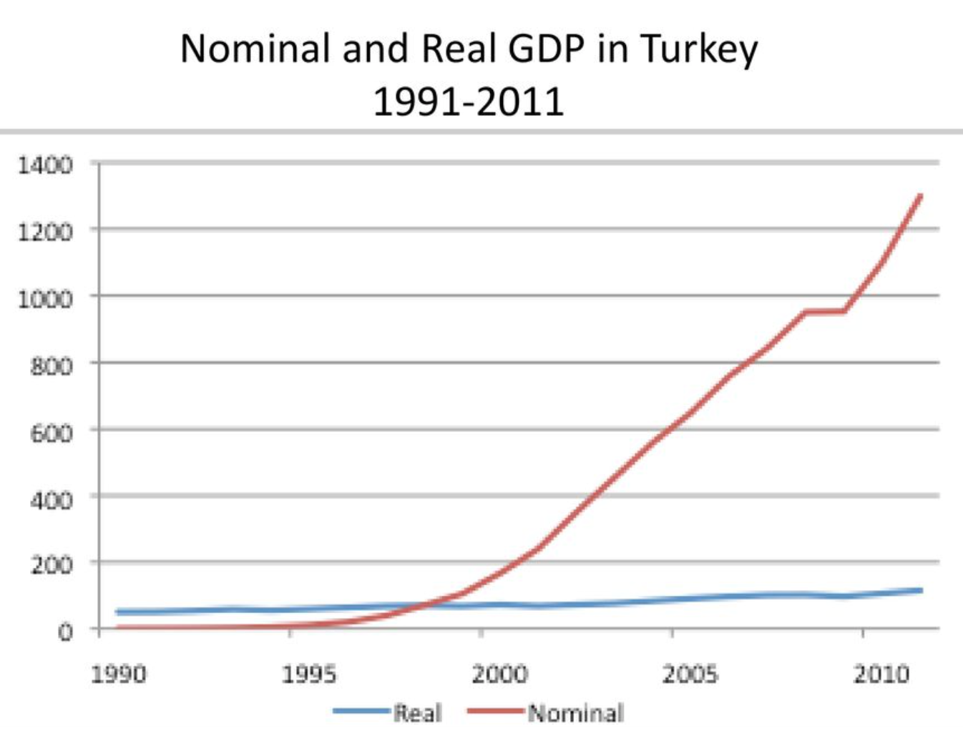

***11. Based on the above graph which shows nominal and real GDP, we can claim that:***

a) Prices rose in Turkey

b) Prices fell in Turkey

**Short Essay Prompts**

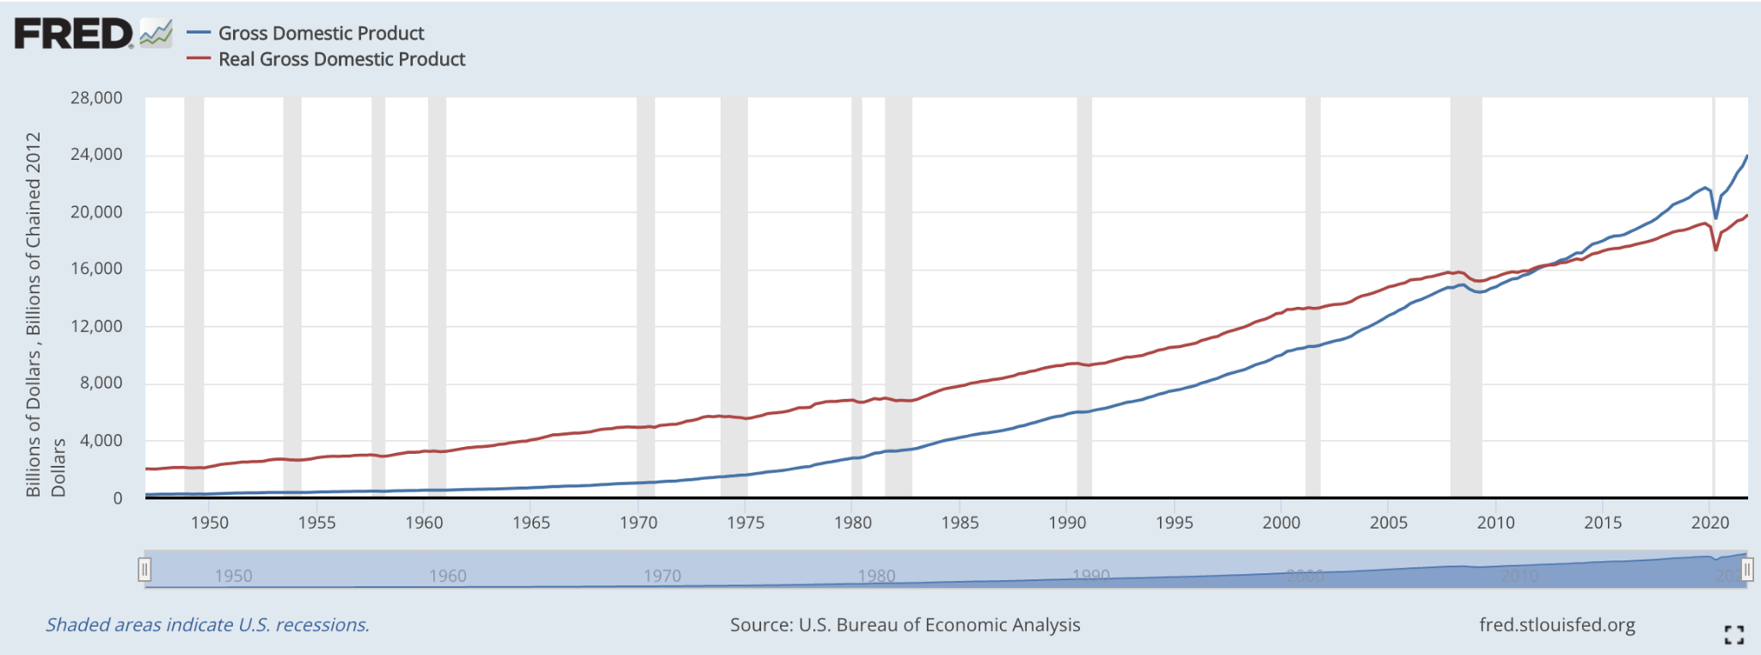

***12. Using the above graph, name one period in U.S. history when Real GDP decreased?***

2020 or 2008 would be acceptable answers.

***13. What are some reasons why real GDP per capita is a good measure of a country’s living standards? What are some reasons why it is not?***

GDP measures the size of a country’s economy. It tends to be correlated with other important measures like life expectancy and education. However, work that is done outside the market is not included in GDP (for instance, childcare). GDP per capita is also an average, therefore it says nothing about the shape of the distribution (i.e. income inequality).